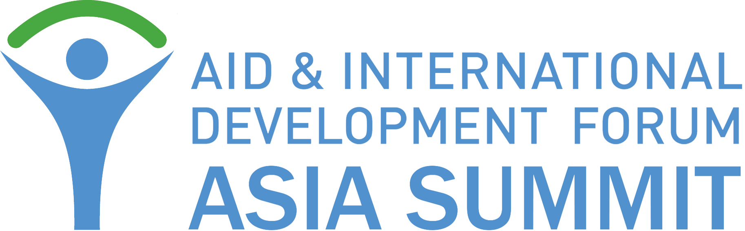
14-15 June 2017
Naypyitaw, Myanmar (Burma)
http://asia.aidforum.org
SOCIAL MEDIA CALENDAR
This is a proposed guide to supporting the Aid & Development Asia Summit on social media. If you have any questions, contact Alina O’Keeffe, Head of Marketing at aokeeffe@aidforum.org
When talking about the Aid & Development Asia Summitonline, we would like to ask you to include event hashtag #AIDFAsiaand website http://asia.aidforum.org
Twitter is our key social media platform. If you haven’t done so yet, please @FollowAIDF or @AlinaAIDF to receive latest updates. Also, join AIDF Facebook page and LinkedIn Group.
Your support with spreading the word is much appreciated!
Any time/ ongoing | - General tweets to announce Aid & Development Asia Summit 2017  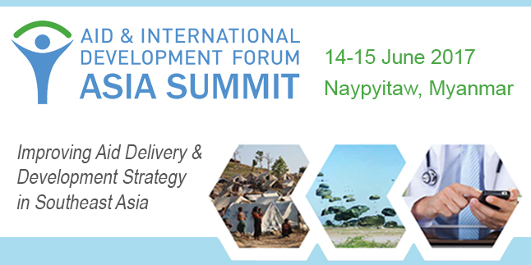  Join 250+ humanitarians to discuss how to improve aid deliveryand development strategy in Asia #AIDFAsiahttps://goo.gl/Am9k4S  Discover innovative solutions that support development strategy in Asia – join #AIDFAsia Summit #Myanmar https://goo.gl/Am9k4S  Hear an update on mobile for development programmes in #SoutheastAsiahttps://goo.gl/Am9k4S#m4d #AIDFAsia  Register now, don’t miss out on the latest humanitarian initiatives at #AIDFAsia Summit, 14-15 June #Myanmar https://goo.gl/Am9k4S  #AIDFAsia Improving health resilience in Southeast Asia through collaboration and technological innovation https://goo.gl/Am9k4S  Find out what topics will be discussed at #AIDFAsia Summit 2017. Visithttps://goo.gl/Am9k4S@FollowAIDF  #AIDFAsia focuses on building successful public-private-people partnerships in humanitarian sector https://goo.gl/Am9k4S
Partnership | Delighted to be part of the Aid & Development Asia Summit on 14-15 June in #Myanmar #AIDFAsiahttps://goo.gl/Am9k4S  Meet us at the 3rd annual #AIDFAsiaSummit in #Myanmar this June. Register your participation at https://goo.gl/Am9k4S  We are proud to support #AIDFAsia Summit, join us in #Naypyitaw in #Myanmar on 14-15 June, register at https://goo.gl/Am9k4S  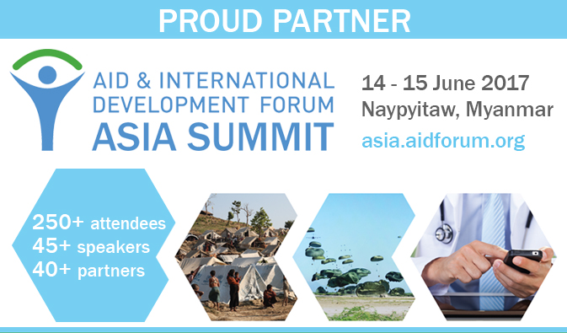
Week starting
22nd May | Discover innovative solutions that support development strategy in Asia – join #AIDFAsia Summit #Myanmar https://goo.gl/Am9k4S  Learn from best practice, latest initiatives & innovations in humanitarian sector in #Asia at #AIDFAsia Summit https://goo.gl/Am9k4S  #AIDFAsia Summit focus on building a culture of resilience and strengthening #disaster preparedness https://goo.gl/Am9k4S  Latest trends in mobile technology, humanitarian logistics, health & WASH, shelter at #AIDFAsia Summit https://goo.gl/Am9k4S  Find out what’s required to enable efficient development assistance in Southeast Asia – join #AIDFAsiahttps://goo.gl/Am9k4S
29th May | How technological innovations and best practice can improve aid delivery and development in #Asia #AIDFAsiahttps://goo.gl/Am9k4S  Register now, don’t miss out on the latest aid delivery initiatives at #AIDFAsia Summit, 14-15 June #Myanmar https://goo.gl/Am9k4S  Learn how technological innovations & best practice can improve aid & development in Asia https://goo.gl/Am9k4S#AIDFAsia  Only 2 weeks left until the #AIDFAsia Summit 2016 at the UNCC in Bangkok hosted by @FollowAIDF register at asia.aidforum.org  Meet us at the 3rd annual #AIDFAsia Summit in #Myanmar this June. Register your participation at https://goo.gl/Am9k4S  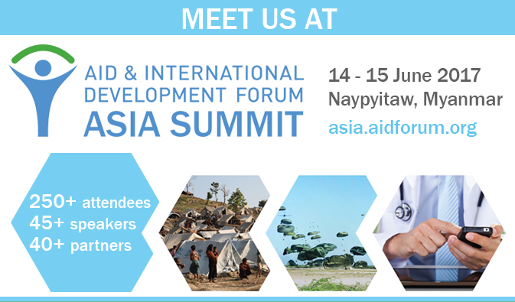
5th June | Discover innovations, partnerships and policy updates for #disaster/flood risk reduction https://goo.gl/Am9k4S#AIDFAsia  #AIDFAsiaSummit is fast approaching. Only a few places left! Book yours now at https://goo.gl/Am9k4S@FollowAIDF  One week left until Aid & Development Asia Summit 2017 in #Myanmar hosted by @FollowAIDFhttps://goo.gl/Am9k4S #AIDFAsia  Meet 250+ NGOs, UN representatives, humanitarians & business leaders at the #AIDFAsia Summit 2017 https://goo.gl/Am9k4S  #AIDFAsia Summit opens next week to welcome 250+ NGOs, UN, government & business leaders in Asia https://goo.gl/Am9k4S
12th June | Join 250+ humanitarians to discuss how to improve aid delivery and development strategy in Asia #AIDFAsiahttps://goo.gl/Am9k4S  Latest trends in emergency communications, early warning systems & data collection #AIDFAsiahttps://goo.gl/Am9k4S  Tomorrow @FollowAIDF will host 3rd Aid & Development Asia Summit in #Myanmar https://goo.gl/Am9k4S#AIDFAsia  Will you be in Naypyitaw in Myanmar this June for the #AIDFAsia Summit 2017? @FollowAIDFhttps://goo.gl/Am9k4S
14-15 June | We will be live tweeting, please follow @FollowAIDF and tag any of your post #AIDFAsia for a retweet!
Thank you for your support!

